

Mossley Hollins High School

Spanish Preparation Workbook

2024



Nombre: _________________

**¡Hola y bienvenidos a Español a Mossley Hollins!**

The Modern Foreign Language faculty will be pleased to welcome you to Mossley Hollins in September, but before you join us there are a few things we would like you to do. So that we can make a fantastic start in Year 7 we would like you to spend some time over the summer learning the basics of Spanish. Please work through this booklet on the topics of:

* Numbers 1-100
* Colours
* Days
* Months
* Animals
* Sports
* Food
* Opinions
* Adjectives
* Connectives

Each topic has an introduction to the vocabulary we would like you to learn, an activity page and a link to a Quizlet. Quizlet is a wonderful website for learning Spanish vocabulary and if you type the address in very carefully, you will be taken to a number of fun activities, which will help you to learn the new words. If you hand a completed booklet into your Spanish teacher on your first lesson, you will receive a PRIDE point.

See you in September!

|  |  |  |  |  |  |  |  |  |  |  |
| --- | --- | --- | --- | --- | --- | --- | --- | --- | --- | --- |
| **~ Las cifras / los números ~**  ***(JD:01/2010)*** | **0**  **cero** | **10**  **diez** | **20**  **veinte** | **30**  **treinta** | **40**  **cuarenta** | **50**  **cincuenta** | **60**  **sesenta** | **70**  **setenta** | **80**  **ochenta** | **90**  **noventa** |
| **1**  **uno** | **11**  **once** | **21**  **veintiuno** | **31**  **treinta**  **y uno** | **41**  **cuarenta**  **y uno** | **51**  **cincuenta**  **y uno** | **61**  **sesenta**  **y uno** | **71**  **setenta**  **y uno** | **81**  **ochenta**  **y uno** | **91**  **noventa**  **y uno** |
| **2**  **dos** | **12**  **doce** | **22**  **veintidós** | **32**  **treinta**  **y dos** | **42**  **cuarenta**  **y dos** | **52**  **cincuenta**  **y dos** | **62**  **sesenta**  **y dos** | **72**  **setenta**  **y dos** | **82**  **ochenta**  **y dos** | **92**  **noventa**  **y dos** |
| **3**  **tres** | **13**  **trece** | **23**  **veintitrés** | **33**  **treinta**  **y tres** | **43**  **cuarenta**  **y tres** | **53**  **cincuenta**  **y tres** | **63**  **sesenta**  **y tres** | **73**  **setenta**  **y tres** | **83**  **ochenta**  **y tres** | **93**  **noventa**  **y tres** |
| **4**  **cuatro** | **14**  **catorce** | **24**  **veinticuatro** | **34**  **treinta**  **y cuatro** | **44**  **cuarenta**  **y cuatro** | **54**  **cincuenta**  **y cuatro** | **64**  **sesenta**  **y cuatro** | **74**  **setenta**  **y cuatro** | **84**  **ochenta**  **y cuatro** | **94**  **noventa**  **y cuatro** |
| **5**  **cinco** | **15**  **quince** | **25**  **veinticinco** | **35**  **treinta**  **y cinco** | **45**  **cuarenta**  **y cinco** | **55**  **cincuenta**  **y cinco** | **65**  **sesenta**  **y cinco** | **75**  **setenta**  **y cinco** | **85**  **ochenta**  **y cinco** | **95**  **noventa**  **y cinco** |
| **6**  **seis** | **16**  **dieciséis** | **26**  **veintiséis** | **36**  **treinta**  **y seis** | **46**  **cuarenta**  **y seis** | **56**  **cincuenta**  **y seis** | **66**  **sesenta**  **y seis** | **76**  **setenta**  **y seis** | **86**  **ochenta**  **y seis** | **96**  **noventa**  **y seis** |
| **7**  **siete** | **17**  **diecisiete** | **27**  **veintisiete** | **37**  **treinta**  **y siete** | **47**  **cuarenta**  **y siete** | **57**  **cincuenta**  **y siete** | **67**  **sesenta**  **y siete** | **77**  **setenta**  **y siete** | **87**  **ochenta**  **y siete** | **97**  **noventa**  **y siete** |
| **8**  **ocho** | **18**  **dieciocho** | **28**  **veintiocho** | **38**  **treinta**  **y ocho** | **48**  **cuarenta**  **y ocho** | **58**  **cincuenta**  **y ocho** | **68**  **sesenta**  **y ocho** | **78**  **setenta**  **y ocho** | **88**  **ochenta**  **y ocho** | **98**  **noventa**  **y ocho** |
| **9**  **nueve** | **19**  **diecinueve** | **29**  **veintinueve** | **39**  **treinta**  **y nueve** | **49**  **cuarenta**  **y nueve** | **59**  **cincuenta**  **y nueve** | **69**  **sesenta**  **y nueve** | **79**  **setenta**  **y nueve** | **89**  **ochenta**  **y nueve** | **99**  **noventa**  **y nueve** |

**100 = cien 1000 = mil**

**Quizlet Link**

https://quizlet.com/_4xjkav

**Spanish numbers 1-100**

Firstly, study the numbers 1-100 on the previous page. Then go to the Quizlet on numbers 1-100 and get some practice by playing the games. Finally, have a go at the tasks below.

Task 1

Write the following numbers in words in Spanish

1 _______________________ 41_______________________

24 ______________________ 11_______________________

57_______________________ 39 ______________________

100______________________ 65_______________________

18_______________________ 76_______________________

20_______________________ 94_______________________

83_______________________ 5 ________________________

Task 2

Do the following sums, write your answer in Spanish words

1. ocho + dos = _________ 6. tres + cuarenta = _________
2. veinte – once =________ 7. diez x cinco = _________
3. nueve x dos = ________ 8. doce – seis = _________
4. cien – diez = _________ 9. diecinueve – ocho = _________
5. dos x ocho = ­­_________ 10. setenta + treinta = _________

Task 3

Put the following numbers in order in the space to the right. Start with the smallest number.

Ocho

veinte

dieciséis

cien

noventa

tres

once

cuarenta y uno

sesenta y siete

veintiséis

**100 = cien 1000 = mil**

**Quizlet Link**

https://quizlet.com/_4yqp5i

**Colours in Spanish**

Look at the colours on the previous page. Follow the link to the Quizlet on colours and play some games to practice them. Lastly, have a go at the tasks below.

Task 1

Match each colour to the word in Spanish:

 

naranja

gris

rojo

verde

marrón

rosa

amarillo

blanco

azul

negro

Task 2

Write the following colours in Spanish:

blue = ________________________ grey = _______________________

yellow = ______________________ red = _______________________

green = _______________________ brown = _____________________

white = _______________________ black = ______________________

orange = ______________________ pink = _______________________

Task 3

Write the missing letters to reveal each colour in Spanish:



_l_n_ _

a_ar_ _l_



n_gr_

_o_ a

r_j_

_ri_

_z_ _

_ar_ _n

_ar_n_a

v_ _d_

Can you draw and label the Spanish flag in Spanish in the space below?

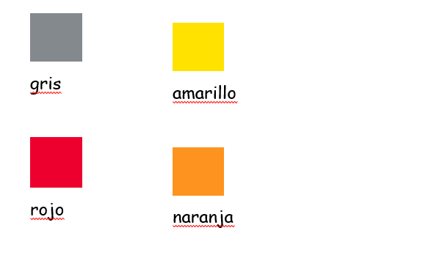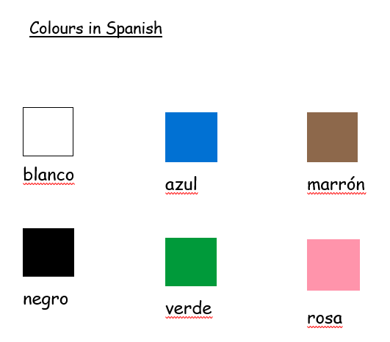

naranja

rojo

amarillo

gris

rosa

verde

negro

marrón

azul

blanco

**Quizlet Link**

https://quizlet.com/_4yr4rr

**Months of the year in Spanish**

Follow the link to the Quizlet on months of the year and play some of the games to practice. Then, try the tasks below using what you have studied.

Task 1

Find the correct months of the year in Spanish, to match the English.

|  |  |
| --- | --- |
| January ____________________ | agosto |
| February ____________________ | diciembre |
| March ____________________________ | junio |
| April _______________________ | noviembre |
| May ________________________ | octubre |
| June _______________________ | enero |
| July ________________________ | septiembre |
| August ______________________ | marzo |
| September ___________________ | mayo |
| October _____________________ | febrero |
| November ____________________ | julio |
| December ____________________ | abril |

Task 2

Rearrange the letters to find the month of the year, in Spanish:

niuoj ___________________________

mediiebcr ________________________

iebpsetmre _______________________

gatoos ___________________________

oamy ____________________________

ujiol ____________________________

venombire ________________________

zmrao ___________________________

eeorn _________________________

cotbrue _______________________

barli __________________________

efberro ________________________

Task 3

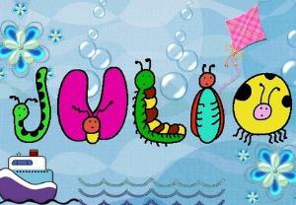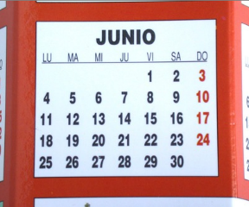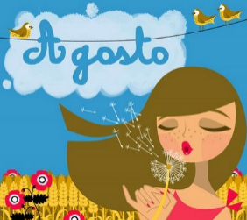Write the month of the year in Spanish, which matches each picture:

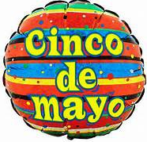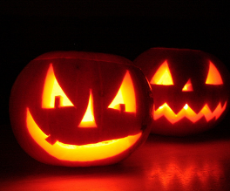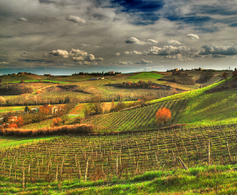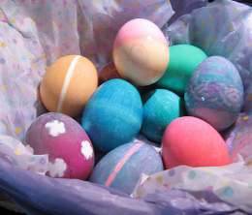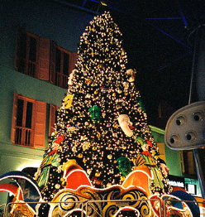

**Quizlet Link**

https://quizlet.com/_4yqt07

**Spanish days of the week**

Follow the link to the Quizlet on days of the week and practice them by playing some games. Then, have a go at the tasks below using what you know.

Task 1

Match the following days of the week in English with the Spanish.

Monday domingo

Tuesday miércoles

Wednesday viernes

Thursday martes

Friday sábado

Saturday lunes

Sunday jueves

Task 2

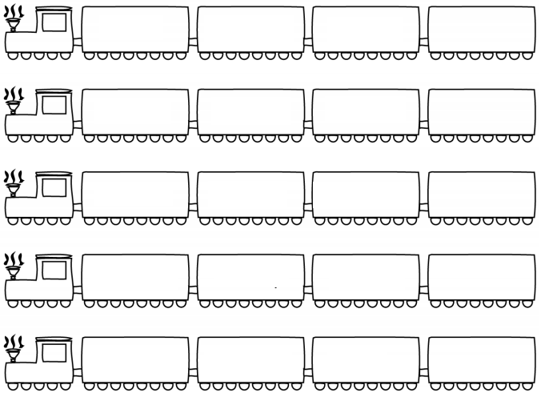Write the day of the week that follows, in Spanish:

miércoless

martes

lunes

domingo

lunes

sábado

domingo

sábado

viernes

viernes

jueves

miércoless

sábado

viernes

jueves

**Quizlet Link**

https://quizlet.com/_4yrnou

**Animals in Spanish**

Look at the animals on the previous page. Carefully type the link to the Quizlet on animals and play some games to practice them. Lastly, once you feel confident, have a go at the tasks below.

Task 1

Write the following animals in Spanish:

a snake = ______________________ a guinea pig =__________________

a fish = ______________________ a rabbit = _____________________

a dog = _______________________ a mouse = _____________________

a tortoise = ____________________ a hamster = ___________________

a horse = ______________________ a bird = ______________________

a cat = _______________________

Task 2

Match each picture to the correct word in Spanish for each animal:



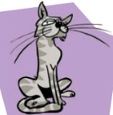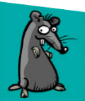

un hámster

un ratón

un pájaro

un gato

un pez

un conejo

un caballo

una serpiente

una cobaya

una tortuga

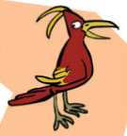



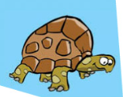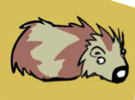

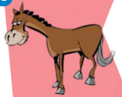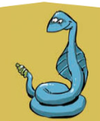

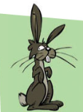

Task 3

Rearrange the letters to find the word for each animal in Spanish:



nu agot

___________

nu jocneo

___________



nu lbcaalo

___________

nu jparáo

___________

nu sáehmtr

___________

nua bcoaay

___________

nu rpeor

___________

nau eesrintpe

___________

nu óratn

___________

nu pze

___________

nua ogtruat

___________

Animals in Spanish





un pájaro= a bird

un gato = a cat



una cobaya = a guinea pig

un perro = a dog





un conejo = a rabbit

un caballo = a horse



un pez = a fish

un ratón = a mouse





una tortuga = a tortoise

un hámster = a hamster



una serpiente = a snake

**Quizlet Link**

https://quizlet.com/_4yvusk

**Spanish sports**

Look at the sports on the previous page. Use the link above to access the Quizlet on sports and play some games to practice them. Once you have done that, have a go at the tasks below.

Task 1

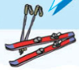Draw a line from each picture, to the word in Spanish in the box:

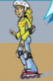 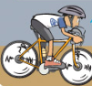

el atletismo

el ciclismo

la equitación

el esquí

la natación

el patinaje

el baloncesto

el fútbol

el hockey

el tenis

el voleibol

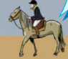

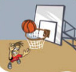

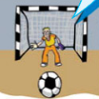



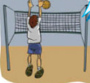

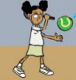

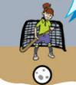

Task 2

Write the following sports in Spanish:

volleyball = ____________________ horse-riding = _________________

football = ______________________ tennis = _____________________

hockey = _______________________ athletics = ___________________

swimming = _____________________ skiing = ______________________

skating = ______________________ basketball = ___________________

cycling = ______________________

Task 3

Write the missing letters:



_l f_tb_ _

e_ _e_i_



l_ e_ _i_a_ió_

e_ _sq_ _



e_ _tl_t_ _ _ _

_l p_t_na_ _

e_ c_cli_m_

_l v_le_b_ _



e_ _al_nc_s_o

_a _at_c_ó_

_l _o_ _e_

Sports in Spanish





el tenis = tennis

la equitación = horse-riding

el atletismo = athletics

el patinaje = skating



el esquí = skiing

el voleibol = volleyball



el hockey = hockey

el baloncesto = basketball





la natación = swimming

el ciclismo = cycling



el fútbol = football

**Quizlet Link**

https://quizlet.com/_4z0zl0

**Food and drink in Spanish**

Look at the food and drink on the previous page. Follow the link to the Quizlet on food and drink and play some games to practice them. Lastly, have a go at the tasks below.

Task 1

Write the following food in Spanish:

a sandwich = ___________________ some crisps = _________________

a banana = _____________________ water = ______________________

a hamburger = __________________ an orange juice = _______________

a pizza = ______________________ an apple juice = _________________

an apple = ______________________ a salad = ______________________

Task 2

Draw a line from each picture to the correct word in Spanish for each food or drink:

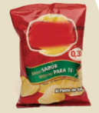

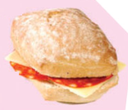

un zumo de naranja

agua mineral

unas patatas fritas

una manzana

una hamburguesa

un bocadillo

una ensalada

una pizza

un zumo de manzana

un plátano

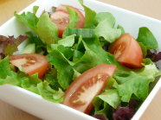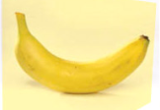

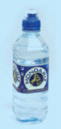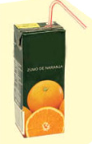

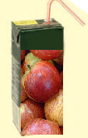





Task 3

Rearrange the letters to find the word for each food or drink in Spanish:

nua gmhauruesab

___________

nu coboaildl

___________





nu mzuo ed nmnzaaa

___________

nusa tpaatas triasf

___________

nu uzom ed jrnaana

___________

nua zpiaz

___________

nau zmanana

___________

nua dlensaaa

___________

gaau ilnmera

___________

nu táplaon

___________

Food and drink in Spanish



una hamburguesa = a hamburger

un bocadillo = a sandwich



una manzana = an apple

una ensalada = a salad

una pizza = a pizza

un zumo de manzana = an apple juice

agua mineral = water

unas patatas fritas = some crisps

un plátano = a banana

un zumo de naranja = an orange juice

**Quizlet Link**

https://quizlet.com/177723961

**Positive and negative adjectives in Spanish**

Follow the link to the Quizlet on positive and negative adjectives and play some of the games to practice. Then, try the tasks below using what you have studied.

Task 1

Find the correct adjectives in English, to match the Spanish.

Positive:

|  |  |
| --- | --- |
| emocionante ____________________ | wonderful |
| estupendo ______________________ | impressive, amazing |
| fenomenal ______________________ | exciting |
| genial _________________________ | great |
| impresionante ___________________ | fantastic |

Negative:

|  |  |
| --- | --- |
| aburrido ______________________ | unpleasant |
| desagradable ___________________ | awful |
| fatal _________________________ | horrible |
| horroroso _____________________ | terrible |
| terrible ______________________ | boring |

Task 2

Rearrange the letters to find a positive or negative adjective, in Spanish:

etribrle ____________________________

angeil ______________________________

riabrdou ____________________________

orroroosh ___________________________

toeocinamne _________________________

gbaesarddale ________________________

nlnfomeea ___________________________

ltfaa ______________________________

npiranesmiote _______________________

pdtesueno __________________________

Challenge task

Can you use the opinions from the previous section and the adjectives from this section and the phrase (porque son = because they are, or porque es = because it is) to write Spanish opinions on…

1. Los perros

***Me encantan los perros porque son estupendos.***

1. Las tortugas

1. El voleibol
2. El fútbol
3. El athletismo
4. Las haburgesas

**Quizlet Link**

https://quizlet.com/_4z12zv

**Opinions in Spanish**

Follow the link to the Quizlet on opinions and play some of the games to practice. Then, try the tasks below using what you have studied.

Task 1  
Match the picture to the Spanish opinions.

no me gusta nada 

no me gusta 

me gusta

prefiero

me encanta 

odio

me gusta mucho

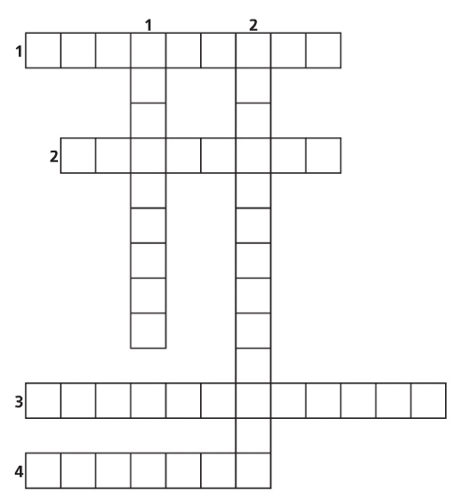Task 2

Complete the crossword with opinions:

1.

2.

3.

4.

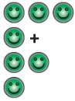**Horizontal**

**Vertical**

1.

2.

**Quizlet Link**

https://quizlet.com/_4z1kpm

**Connectives in Spanish**

Follow the link to the Quizlet on connectives and play some of the games to practice. Then, have a go at the tasks below.

Task 1

Find the correct connectives in English, to match the Spanish.

|  |  |
| --- | --- |
| y _____________________________ | because |
| o _____________________________ | or |
| pero ___________________________ | in addition |
| porque _________________________ | and |
| también ________________________ | also |
| además _________________________ | although, (even) though |
| sin embargo______________________ | given that |
| aunque _________________________ | for example |
| dado que ________________________ | however |
| por ejemplo ______________________ | given that |
| por eso _________________________ | but |

Task 2

Rearrange the letters to find a connective, in Spanish:

opr peemjlo _________________________

qaunue ____________________________

reop ______________________________

nsi rbgemao ________________________

pro ose ____________________________

bétmina ____________________________

oadd ueq ___________________________

rpquoe ____________________________